**NOMATEN ONLINE-SEMINAR**

[**https://www.gotomeet.me/NCBJmeetings/nomaten-seminar**](https://www.gotomeet.me/NCBJmeetings/nomaten-seminar)

Tuesday, NOVEMBER 8th 2022 13:00 CET

**Metastable Structure of Layers Shaped During Pulse Magnetron Sputtering**

Katarzyna Nowakowska-Langier

[Katarzyna.nowakowska-langier@ncbj.gov.pl](mailto:Katarzyna.nowakowska-langier@ncbj.gov.pl)

Plasma and Ion Technologies Division, Materials Physics Department, National Centre for Nuclear Research, Otwock, Poland.

**Abstract:**

The forming the properties of materials consists in fulfilling the sequence of different energy states. First, one should obtain the state of increased free energy, as the excited initial state for subsequent treatments and then conduct controlled relaxation of this energy excess in order to reach a lower level of non-equilibrium energy state of material - defined as a new degree of structure metastability, both in phase and morphological terms. This grade determines the usable properties of the material as a synthesis product. Effectiveness in implementation the above sequence, which is crucial for obtaining the desired properties of materials, is directly dependent on recognition of the synthesis environment. In the case of plasma surface engineering methods, this effectiveness is conditioned by ensuring of high levels of the energy and the degree of non-equilibrity of plasma at the same time. The pulse processes that minimize the risk of uncontrolled arcing and electrode degradation at high power densities are the most advantageous from this point of view. Additionally these conditions create a unique chance for freezing of metastable states of synthesis products on cold substrates, difficult or impossible to achieve by other means. Plasma that meets above-mentioned features I defined as an “active” synthesis environment, because such plasma contains factors that directly determine the possibility of achieving high-energy excitations of primary synthesis products. This talk will give an overview of research results concerning of use pulse magnetron sputtering method in case of synthesis of different metastable layers material.

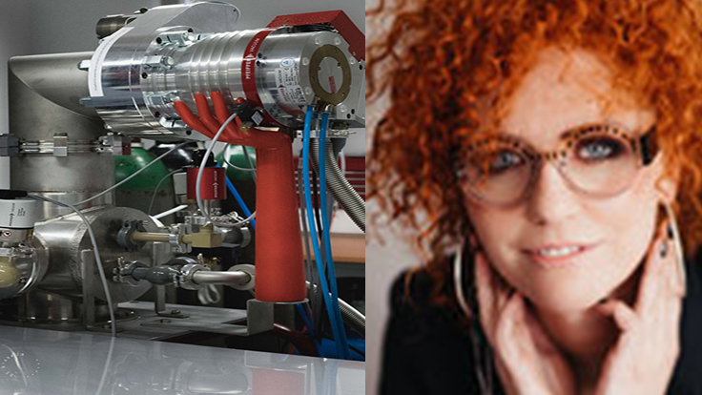

**Bio:**

Katarzyna Nowakowska-Langier works as a professor at the National Centre for Nuclear Research in the

Department of Materials Physics. Currently she is the head of the Plasma and Ion Technologies division. She graduated of the Faculty of Metallurgy and Materials Science, Częstochowa University of Technology (M.Sc degree) and the Faculty of Materials Science and Engineering of the Warsaw University of Technology (Ph.D and D.Sc. degrees). The scope of scientific activity of Katarzyny Nowakowskiej-Langier covers research related to materials engineering, the plasma surface engineering in particular. These are issues related to pulsed plasma in the context of its use in the synthesis of materials and coatings, as well as research, including the effects of interaction with the surface of materials, by actively participating in shaping their structure and properties.