Seminarium Zakładu Energetyki Jądrowej i Analiz Środowiska (UZ3)
Departament Badań Układów Złożonych (DUZ)
Wtorek: 17.01.2023
Wyjątkowo: 14:30
transmisja online:
https://www.gotomeet.me/NCBJmeetings/uz3-and-phd4gen-seminars

Cesar Queral¹and Kevin Fernandez-Cosials^{1,2}
¹Universidad Politécnica de Madrid, ²Texas A&M

Statistical Analysis of NPP transients: LBLOCA in a PWR;
Parametric, non-parametric methods and EBEPU

Abstract:

The Best Estimate Plus Uncertainty (BEPU) approach is being used worldwide for nuclear power plants licensing. This method relies on the use of best estimate models to simulate sequences, evaluating the uncertainties involved. To assess these uncertainties, several methodologies have been developed such as the non-parametric Wilks/Wald method, parametric methods that reconstruct a distribution from the data, or the binomial approach. Additionally, sensitivity analyses can be performed to obtain the correlation of the output-inputs. Finally, a variability analysis of the most influential parameters is made to find a combination of parameters that can lead to damage is also useful. In this seminar, all previous techniques are described, studied and applied by performing a large Monte Carlo set of simulations of a loss of coolant accident in a PWR assessing two figures of merit. Finally, some remarks will be provided on how to employ BEPU coupled with PSA in the new approach of Extended-BEPU (EBEPU).

Serdecznie zapraszamy
Mariusz Dąbrowski, Tomasz Kwiatkowski

http://www.phd4gen.pl

Biographical Notes:

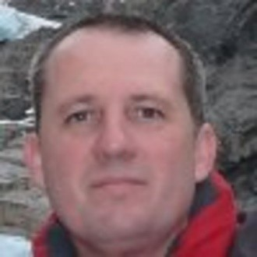
Cesar Queral is a Professor of Nuclear Engineering at Technical University of Madrid (UPM) since 1992 (permanent academic staff since 2001). Head of the Energy Systems Department (2006-2010). He is leading a research team on Nuclear Safety since 1996. Member of the NEA Working Group on Analysis and Management of Accidents (WGAMA) since 2018. Author of more than 45 articles in international scientific journals. About 90 communications to international meetings and 100 to national ones. Director of 12 PhD Thesis, 4 ongoing. He has about 30 years’ experience in the field of safety analysis and has participated in more than 50 projects related with nuclear safety such as CAMP (NRC); OECD/NEA SETH; OECD/NEA PKL; OECD/NEA ROSA; OECD/NEA ROSA-II; OECD/NEA PKL-III; OECD/NEA SM2A; OECD/NEA ATLAS or SARGEN-IV.

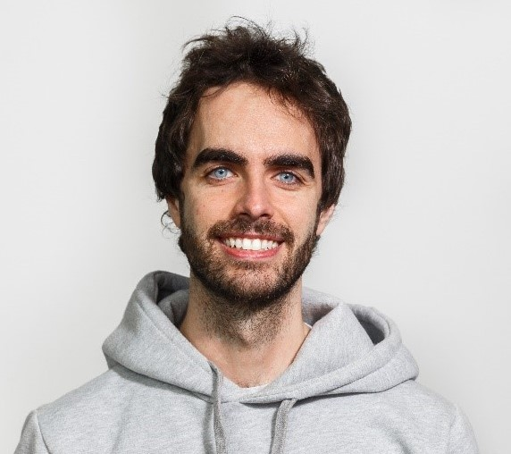
Kevin Fernandez-Cosials is currently a visiting professor in Texas A&M University (TAMU) in the United States, and an assistant professor in the Technical University of Madrid (UPM), Spain. M.Sc. Power Engineering (2015) and PhD in Nuclear Engineering (2017) at the UPM. He has been collaborating and working in Cesar Queral's Lab since 2018. Research Topics are focused on Nuclear Safety, DSA, Severe Accident analysis, Severe Accident Management Guidelines and FLEX Strategies. Over 20 papers in international scientific journals, more than 20 papers/presentations in proceedings of international conferences and dozens of talks in Nuclear Seminars and Workshops.

